Linux System & Network
Administration Lab
Project Documentation
A record of hands-on system and network administration work performed on a self-provisioned Ubuntu virtual machine

Overview
This project was built to gain practical, hands-on experience with core Linux system and network administration tasks rather than studying them in the abstract. I provisioned my own Ubuntu virtual machine and worked through user and permission management, service administration, package management, networking, security hardening, and log analysis, executing every command directly. Where issues arose during the process, the troubleshooting steps are documented alongside the resolution, since diagnosing and resolving real problems was a core part of the exercise.

Environment
- Operating system: Ubuntu 26.04 LTS Desktop
- Hypervisor: Oracle VirtualBox, on a Windows host
- Networking: VirtualBox NAT network (10.0.2.0/24)
- VirtualBox Guest Additions installed for host/guest clipboard integration
Initial VM provisioning and the Ubuntu installation itself are not covered in this document, as they follow the standard installation process and do not reflect administration skills. This write-up begins at the point where hands-on administration work started.

1. Filesystem, Permissions & Users
This section covers the foundational layer that everything else depends on: file ownership, access control, and how user accounts and group membership are structured.
Command | Purpose
ls -la | List files with permissions, ownership, and hidden files included
chmod 700 <dir> | Restrict a directory to owner-only access, using octal notation (read=4, write=2, execute=1 per digit)
useradd -m <user> | Create a new user account, with -m also creating that user's home directory
passwd <user> | Set or change a user's password
usermod -aG sudo <user> | Add a user to the sudo group, appending rather than overwriting existing group memberships
This section also included reviewing the field structure of /etc/passwd and /etc/group, and confirming the distinction between sudo <command>, which authenticates and elevates the invoking user for a single command, and switching to a persistent root shell — a distinction relevant to maintaining least-privilege access.
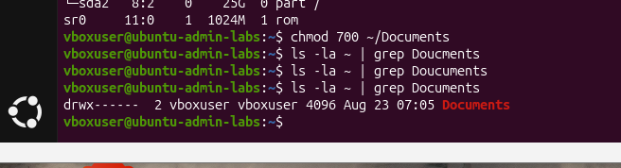
SS/01-filesystem-permissions-chmod-verified.png — chmod 700 applied to ~/Documents, verified with ls -la showing drwx------
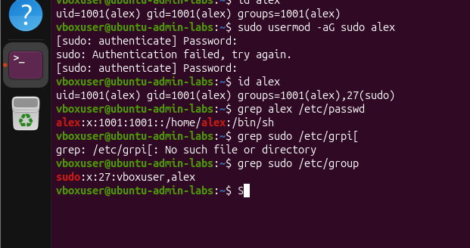
SS/01-filesystem-permissions-user-group-sudo.png — Confirming usermod -aG sudo succeeded via id and /etc/group, and identifying the user's default shell

2. Processes & Services
This section covers inspecting what is currently running on the system, controlling long-running background services, and scheduling recurring tasks.
Command | Purpose
ps aux | Snapshot of every running process on the system
top | Live view of process activity, load average, and CPU/memory usage
systemctl status / enable --now <service> | Check a service's status, and start it immediately while also enabling it to start automatically on every future boot
journalctl -xe | View recent system log entries with added explanation
crontab -e | Edit a user's scheduled jobs, using the five-field time syntax: minute, hour, day-of-month, month, day-of-week
To confirm the cron job was functioning correctly rather than assuming it based on syntax alone, a test job was configured to append a timestamped entry to a log file every minute, with the output verified directly. A stopped background job was also cleared using kill %1, reinforcing the distinction between a shell job number (%1) and a process ID.
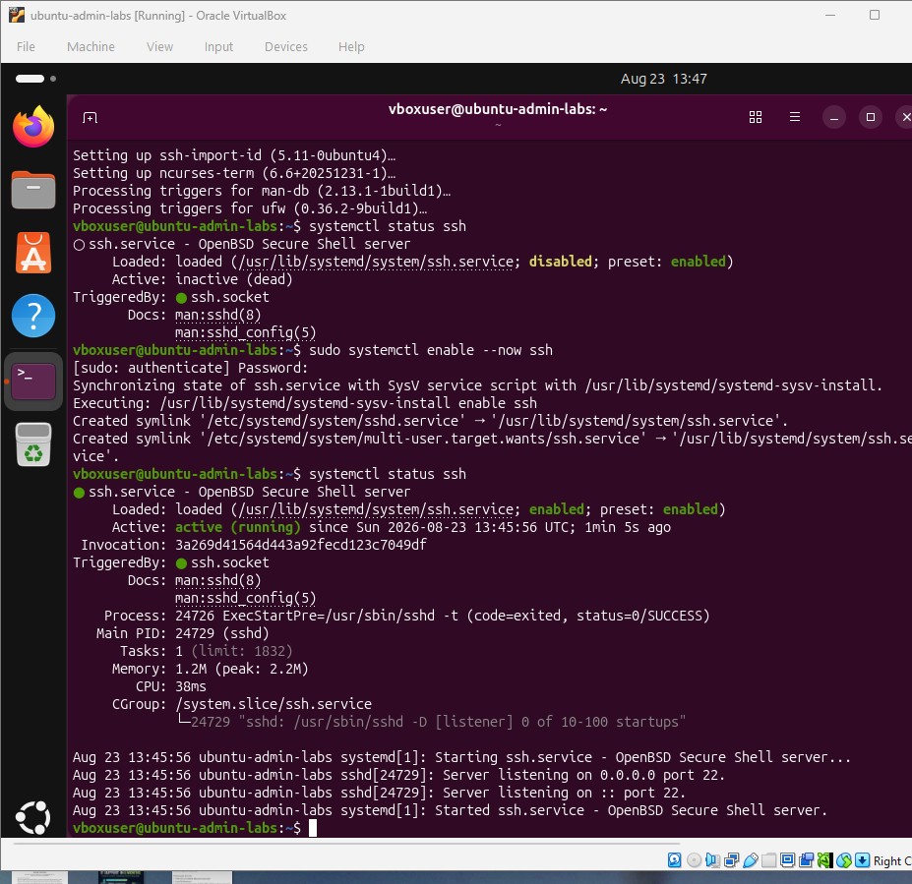
SS/02-processes-services-ssh-active.png — systemctl status ssh after enable --now, confirming the service is active and listening on port 22
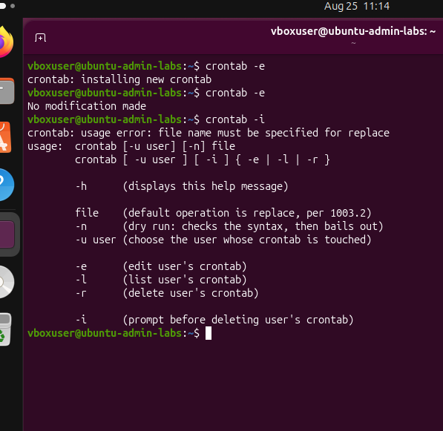
SS/02-processes-cron-crontab-l-verified.png — crontab -l showing the final, correctly saved cron job line
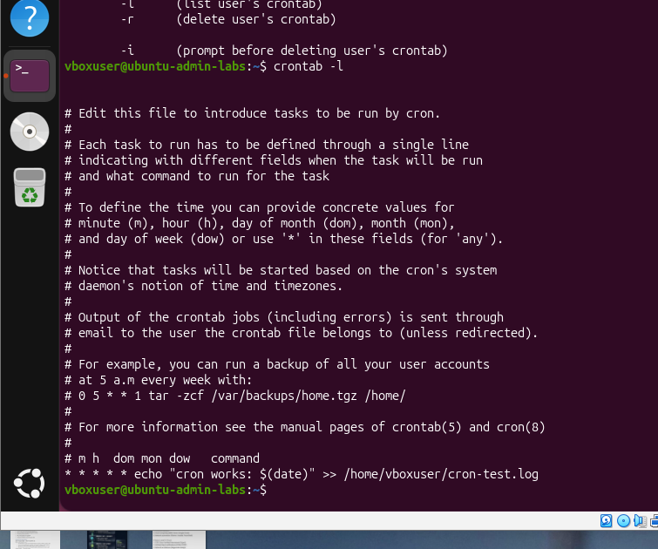
SS/02-processes-cron-test-log-fired.png — cat ~/cron-test.log showing two timestamped entries one minute apart, confirming the job fired on schedule

3. Package Management
Ubuntu's package management is structured in two layers: apt, the high-level tool used for day-to-day installing, updating, and searching; and dpkg, the lower-level tool underneath it, used here primarily for inspecting what is already installed.
Command | Purpose
sudo apt update && sudo apt full-upgrade -y | Refresh the package index, then non-interactively upgrade every package, allowing apt to add or remove packages as needed to satisfy dependency changes
sudo apt install <package> -y | Install a package without an interactive confirmation prompt
apt-cache search <term> | Find packages by matching a keyword against package names and descriptions
dpkg -l | grep <package> | List installed packages, filtered to confirm a specific one is present
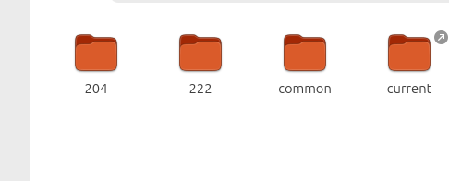
SS/03-package-management-tree-install.png — Installing the tree package and using it to display the home directory as a visual tree, including Snap's versioned package layout
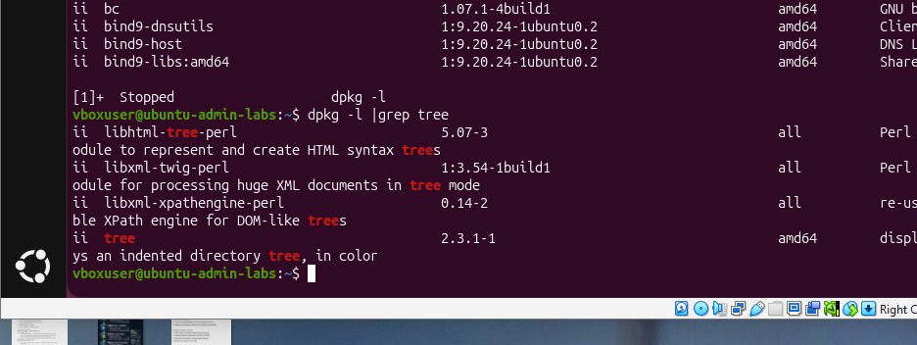
SS/03-package-management-dpkg-verified.png — dpkg -l piped through grep, confirming the tree package is installed with its version and description

4. Core Networking
This section covers addressing, routing, and name resolution — the fundamentals of how the machine communicates on a network.
Command | Purpose
ip a | Show every network interface and its assigned IP address
ip route | Show the routing table, including the default gateway
nmcli device status | NetworkManager's view of active network connections
ping -c 4 <host> | Test basic reachability with a fixed number of packets
dig <domain> | Resolve a domain name and inspect the full DNS response
ss -tulpn | List listening TCP and UDP ports along with the owning process
A key distinction established in this section is between a service bound to 0.0.0.0, which is reachable from other machines on the network, and one bound to 127.0.0.1 (loopback), which is reachable only from processes running on the same machine — a distinction directly relevant to the firewall configuration covered later.
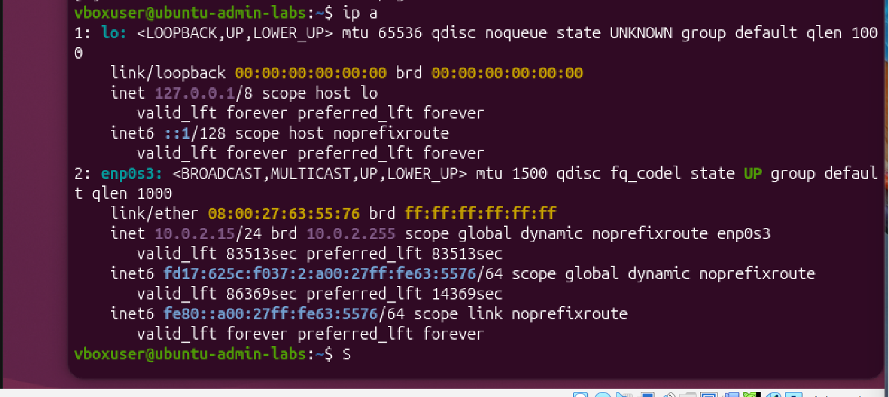
SS/04-networking-ip-a-interface.png — ip a showing the enp0s3 interface with its assigned IP address on the VirtualBox NAT network
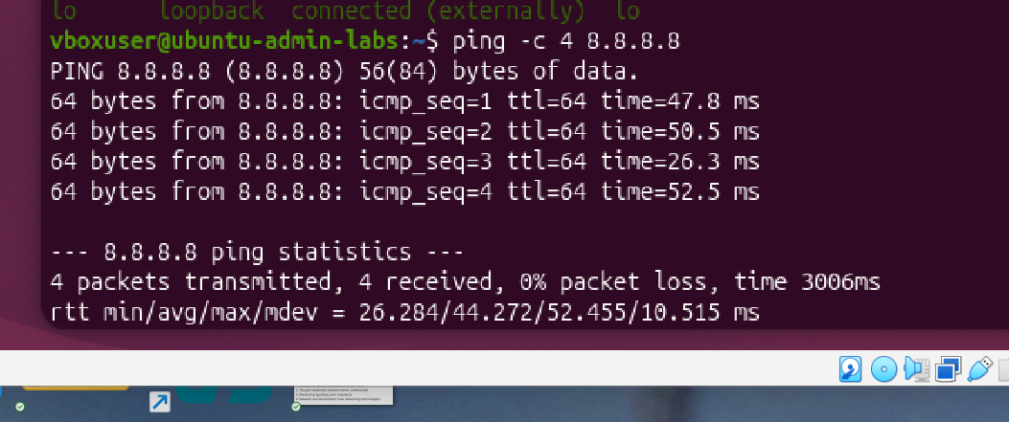
SS/04-networking-ping-8888.png — ping -c 4 8.8.8.8 completing with 0% packet loss, confirming outbound connectivity
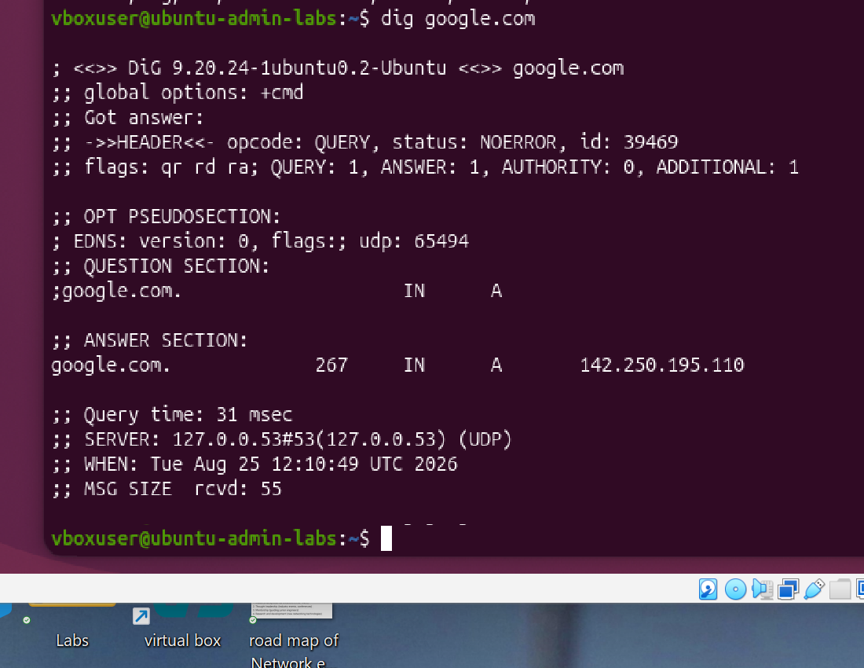
SS/04-networking-dig-google.png — dig google.com, with the ANSWER SECTION showing the resolved A record
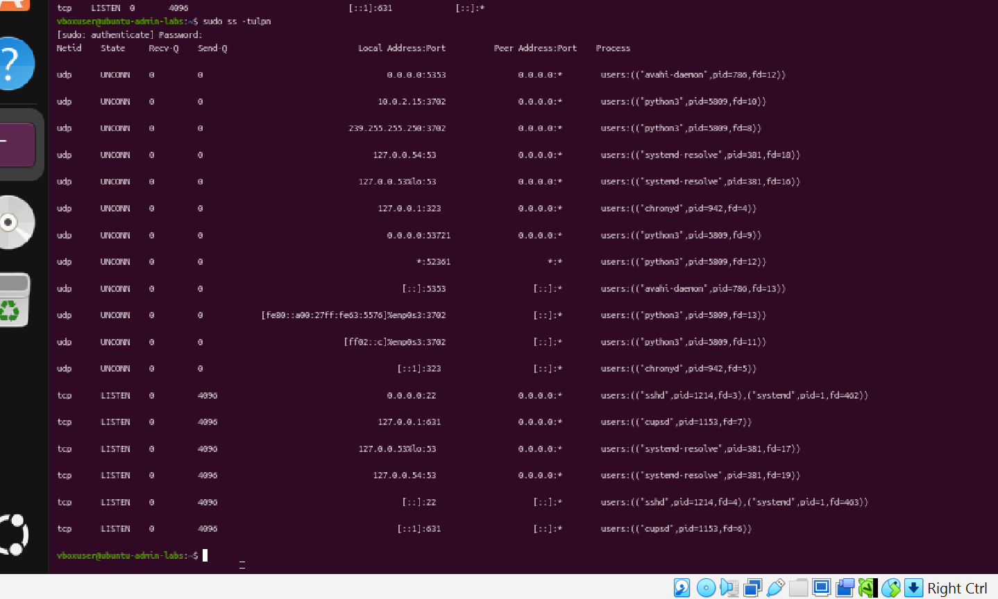
SS/04-networking-ss-tulpn-sudo.png — sudo ss -tulpn showing listening ports with full process names (sshd, cupsd, systemd-resolve)

5. Diagnostics & Recon
This section shifts from reviewing local machine configuration to actively probing the network: discovering live hosts, scanning for open ports and running services, and capturing raw traffic.
Command | Purpose
sudo nmap -sn <subnet> | Host discovery — sweep a subnet to identify which addresses are currently in use, without scanning ports
sudo nmap -sV -p- <host> | Full port scan across all 65,535 ports, with service and version fingerprinting on anything open
sudo tcpdump -i <interface> -c <count> | Capture a fixed number of live packets on a given network interface
nc -zv <host> <port> | Test whether a specific port accepts a connection, without sending any data
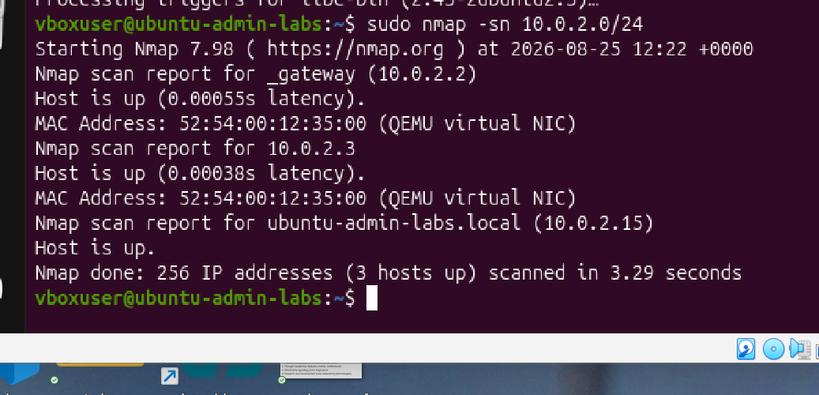
SS/05-diagnostics-nmap-host-discovery.png — sudo nmap -sn across the VirtualBox NAT subnet, identifying the gateway, the DHCP helper, and the VM itself
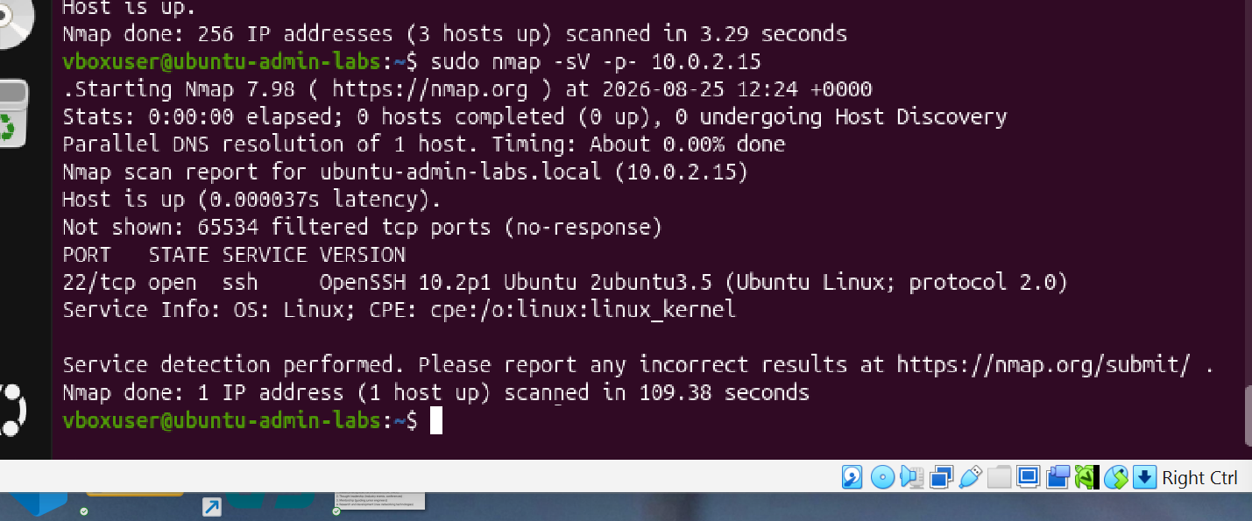
SS/05-diagnostics-nmap-port-scan-ssh.png — Full 65,535-port scan completing with only port 22 open, correctly fingerprinted as OpenSSH
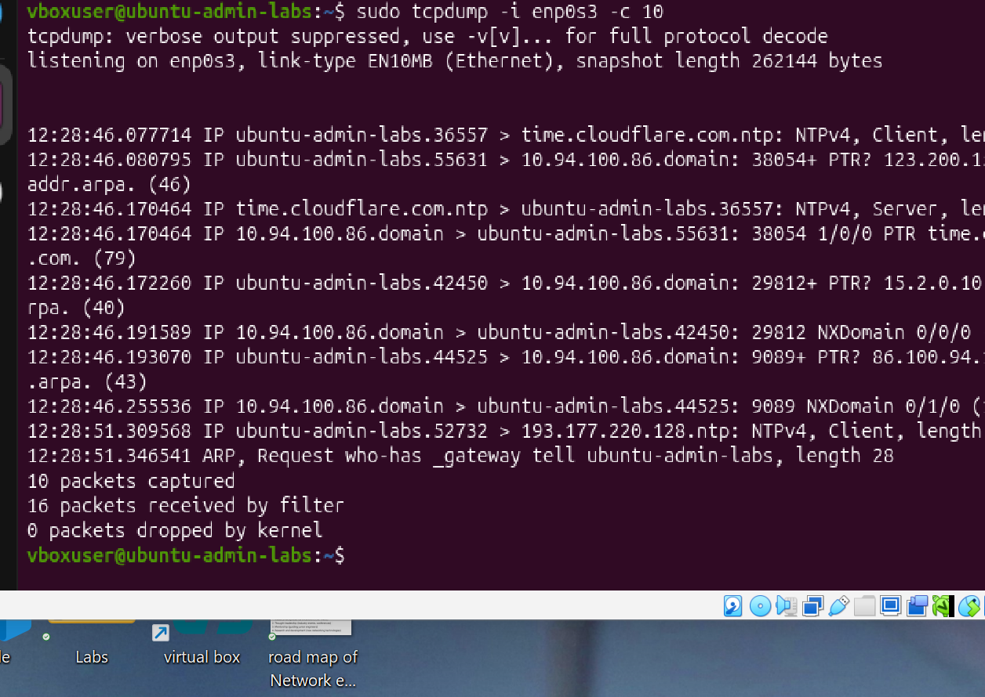
SS/05-diagnostics-tcpdump-capture.png — tcpdump capturing live NTP, DNS, and ARP traffic on the primary network interface

6. Firewalls & Remote Access
This section required particular care: an incorrect order of operations here can result in losing remote access to the machine entirely.
Command | Purpose
sudo ufw allow ssh | Explicitly allow SSH before enabling the firewall, so remote access is not accidentally blocked
sudo ufw enable | Switch the firewall to a default-deny-incoming policy, with outgoing traffic still allowed
sudo ufw status verbose | Review the active policy and every configured rule
ssh <user>@<host> | Open a remote shell session over an encrypted connection
ssh-keygen -t ed25519 | Generate a new public/private key pair for key-based authentication
ssh-copy-id <user>@<host> | Install a public key into the target account's authorized_keys file
/etc/ssh/sshd_config | The server-side SSH policy file, controlling settings such as root login and password authentication
sudo apt install fail2ban -y | Install a service that automatically bans IP addresses after repeated failed login attempts
SSH was explicitly allowed before enabling the firewall, since reversing that order would have removed the access needed to correct any misconfiguration. Key-based authentication was then configured and verified two ways: a login that required no password prompt at all, and confirmation in the authentication log showing "Accepted publickey" rather than "Accepted password."
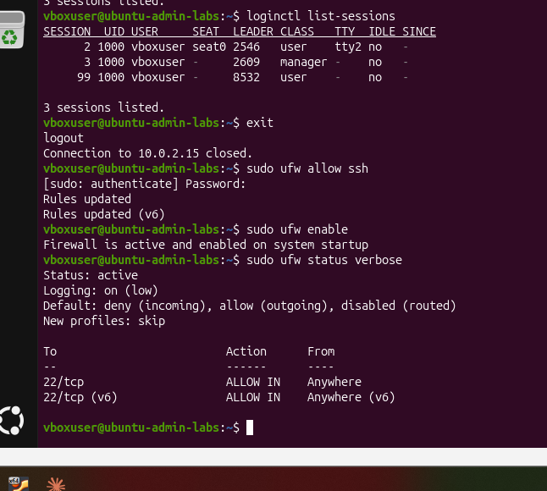
SS/06-firewall-ufw-enabled-sessions.png — ufw allow ssh, enable, and status verbose confirming the firewall is active with only port 22 allowed; loginctl list-sessions distinguishing the console login from the SSH session
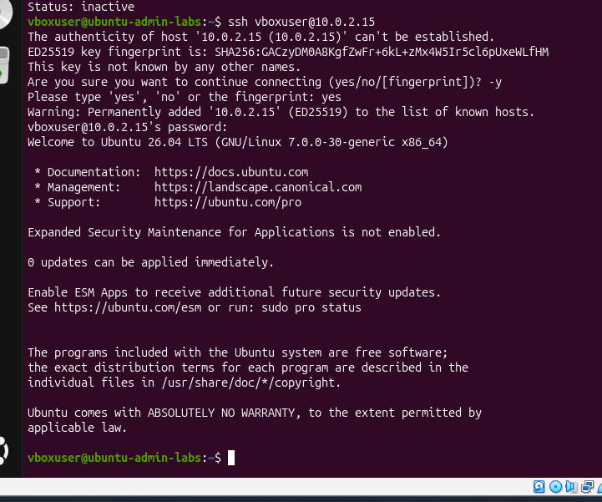
SS/06-firewall-ssh-login-fingerprint.png — First SSH login: host key fingerprint verification, followed by a successful login and the Ubuntu welcome banner
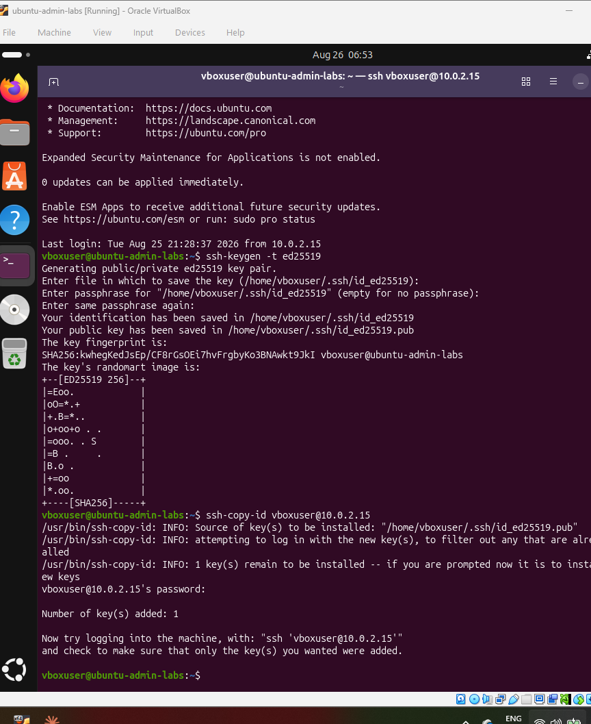
SS/06-firewall-ssh-keygen-ed25519.png — ssh-keygen -t ed25519 generating a new key pair, including its randomart fingerprint image
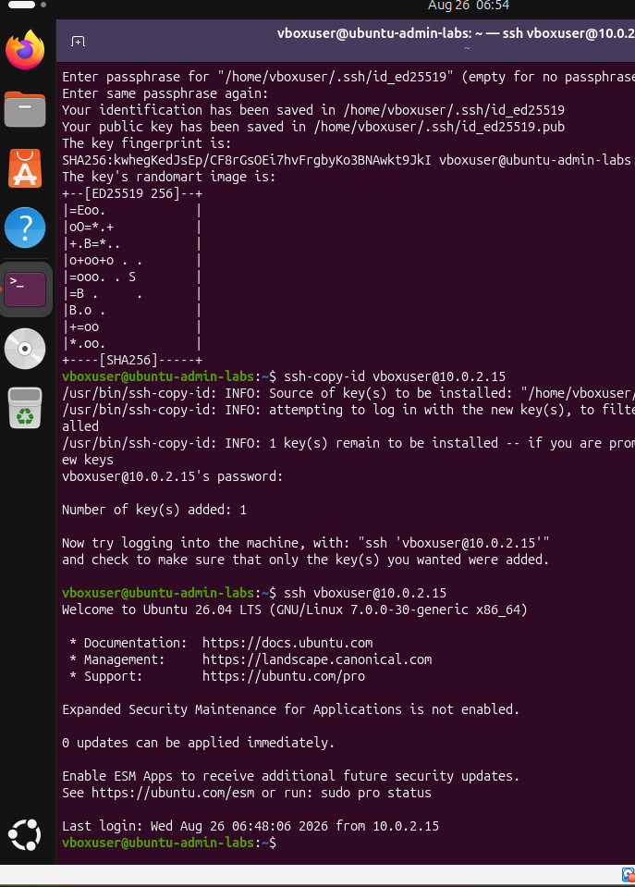
SS/06-firewall-ssh-copy-id-passwordless.png — ssh-copy-id installing the public key, immediately followed by an SSH login with no password prompt at all
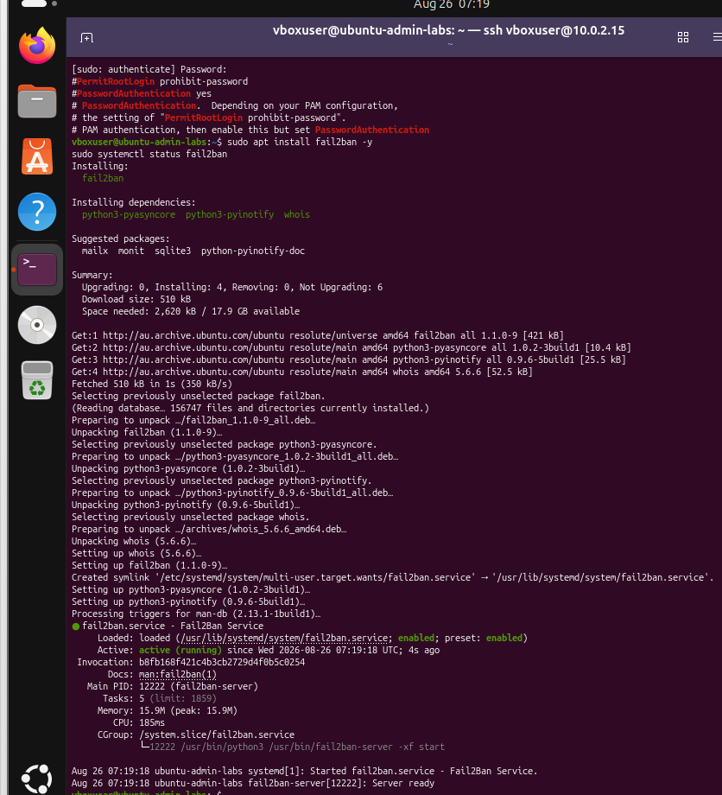
SS/06-firewall-fail2ban-active.png — fail2ban installed and running, actively watching the system's authentication logs

7. Logs & Monitoring
This section covers reviewing the historical record of system activity: authentication events, resource usage, and logs scoped to a single service.
Command | Purpose
sudo tail -n 20 /var/log/auth.log | Review the most recent authentication events: logins, sudo usage, and SSH activity
df -h | Disk space usage per filesystem, in human-readable units
free -h | Memory usage, with the available column indicating what can actually still be used
uptime | System uptime, number of active sessions, and load average
journalctl -u <service> --no-pager | tail -n 20 | Recent log history for one specific systemd service
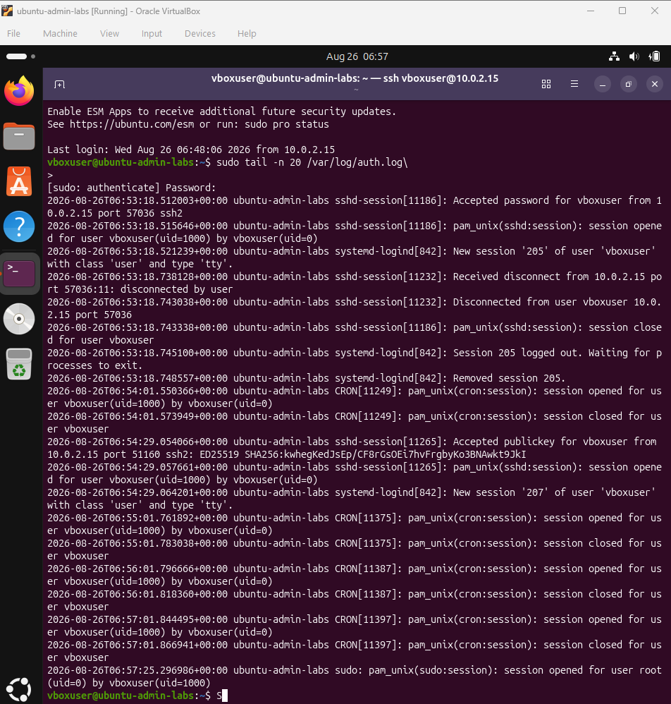
SS/07-logs-auth-log-password-publickey.png — tail -n 20 on the authentication log, showing both a password-based login and a publickey-based login recorded with full detail
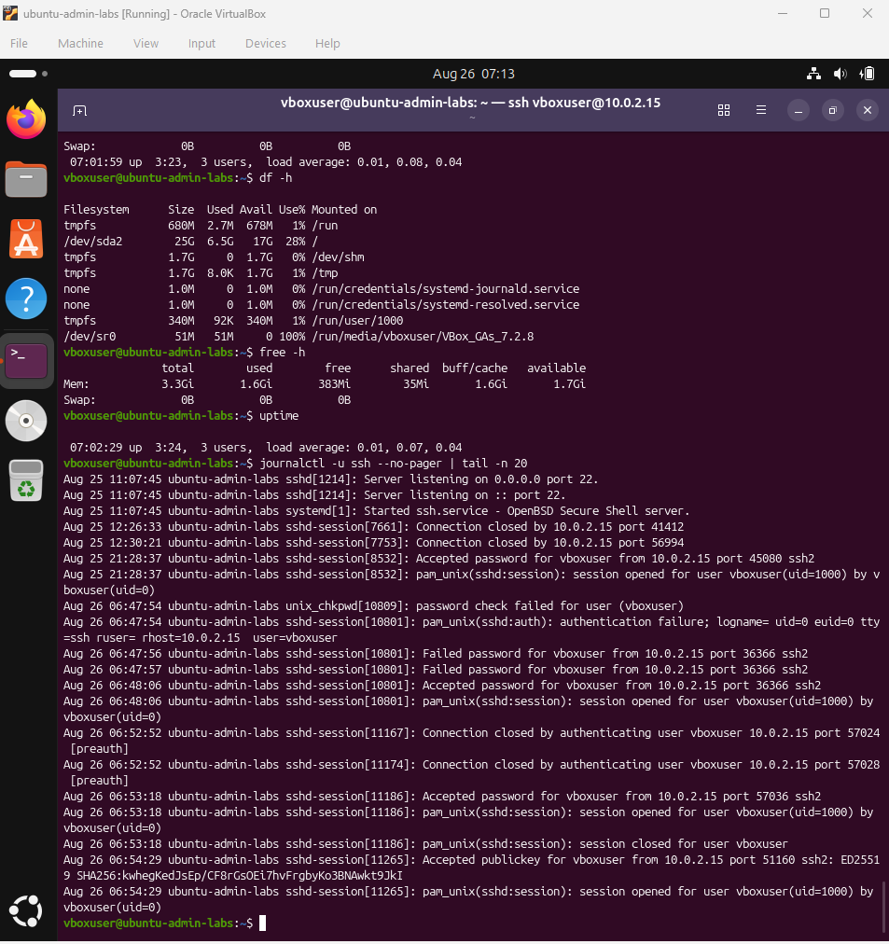
SS/07-logs-journalctl-ssh-history.png — journalctl -u ssh showing detailed SSH session history, including earlier failed password attempts and a later accepted publickey login

8. Bonus: Shell Scripting & Integration
This closing section covers writing and debugging a small bash script, and chaining several tools together to observe a firewall rule take effect in real time.

disk-check.sh
A script that checks root filesystem usage against a configurable threshold and prints a warning if it is exceeded. The finished script is included in this repository as disk-check.sh.
#!/bin/bash
THRESHOLD=80
USAGE=$(df -h / | awk 'NR==2 {print $5}' | tr -d '%')
if [ "$USAGE" -ge "$THRESHOLD" ]; then
echo "WARNING: Disk usage is at ${USAGE}% — above the ${THRESHOLD}% threshold!"
else
echo "OK: Disk usage is at ${USAGE}% — within normal range."
fi
Debugging the script proved more instructive than writing it. Two issues were identified during development: a stray character had been introduced at the start of the shebang line, and the threshold variable had been misspelled on its assignment line (THSRESHOLD instead of THRESHOLD), meaning it was never actually set. Since the comparison further down correctly referenced the properly spelled variable, it silently evaluated against an empty value. This was diagnosed by reviewing the script's actual saved contents with cat rather than assuming the intended text had been entered correctly — a useful general debugging practice.
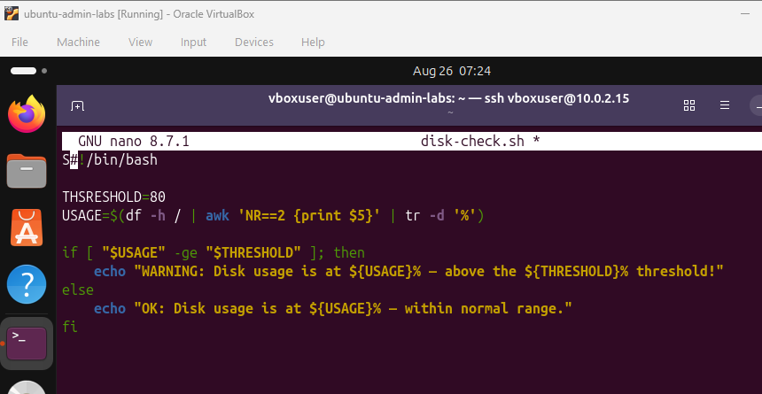
SS/08-bonus-script-bugs-and-fix.png — cat disk-check.sh revealing both bugs, followed by the corrected version after fixing the shebang and the variable name
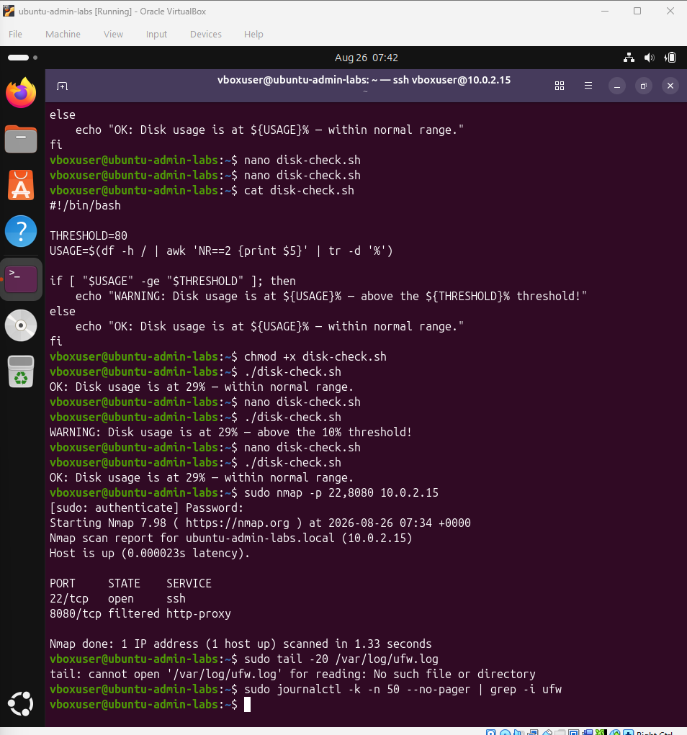
SS/08-bonus-script-ok-warning-final-nmap.png — The corrected script producing both a genuine OK result and, with the threshold temporarily lowered, a genuine WARNING result

Integration exercise: ufw + nmap + journalctl
To directly observe a firewall change take effect rather than assume it based on configuration alone, three tools were used together:
- sudo ufw deny 8080 — explicitly block a specific port
- sudo journalctl -f (in a second terminal) — follow the live system log
- sudo nmap -p 22,8080 <host> — scan both ports, confirming 22 remained open while 8080 changed to filtered
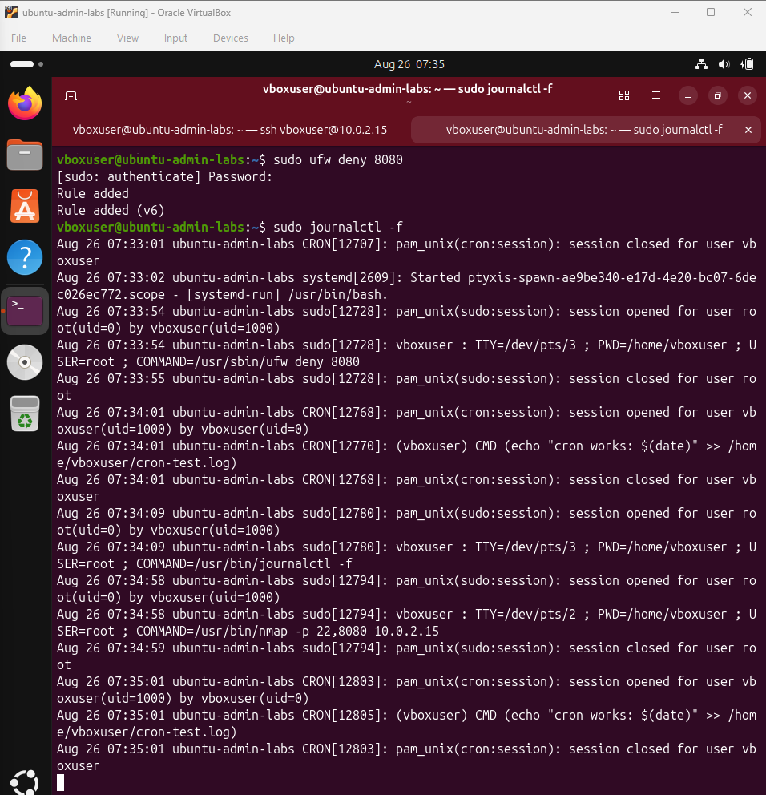
SS/08-bonus-ufw-deny-journalctl-live.png — ufw deny 8080 and journalctl -f, capturing the live, timestamped audit trail of both the firewall change and the nmap scan

Notable Troubleshooting
The following issues were encountered and resolved over the course of this project:
- VirtualBox Guest Additions failed to run when executed directly, because its installer CD is mounted read-only via ISO9660 with the execute permission removed, even for root. Resolved by running the installer through the shell interpreter instead: sudo bash VBoxLinuxAdditions.run.
- sudo reboot was blocked by a systemd inhibitor protecting the active desktop session. Resolved with sudo systemctl reboot -i, where -i explicitly ignores inhibitors.
- A saved crontab initially had no effect because a stray character had been accidentally left at the top of the file during editing. Resolved by removing the bad line in nano before saving.
- disk-check.sh's threshold comparison failed with an "integer expected" error, ultimately traced to a misspelled variable name rather than a logic error, as detailed in the bonus section above — resolved by reading the file's actual saved content rather than assuming the intended text had been entered correctly.

Key Takeaways
- Most of the practical work in this lab involved careful interpretation of command output — the results of ss, nmap, and log files — rather than memorization of syntax.
- The majority of issues encountered were the result of typographical errors or incorrect sequencing, such as enabling the firewall before allowing SSH, rather than gaps in conceptual understanding.
- The same tools used to inspect system state (ps, ss, journalctl) were also used to verify that configuration changes had taken effect, through direct before-and-after comparison.

